Setup
Before extracting the map editor, create a new folder in the infantry directory and name it “Editor”. After unzipping, please place the map editor in this newly created folder. You’ll also need to copy all f_ and o_ .blo files (O for objects and F for floors) from your Infantry directory into this folder. The .BLO files contain all the games visual assets such as Sprites and Floor Tiles.

Before you open the editor, you’ll need to change your desktops color quality to “Medium 16 Bit”. If you do not, your map work area will be filled with green and purple textures.

Example
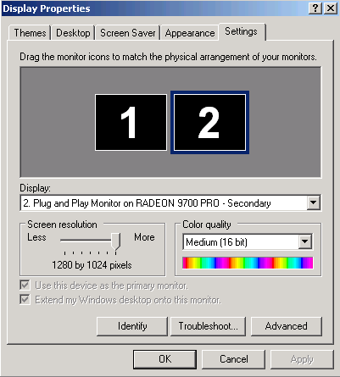

If the editor crashes when opened, Right click and select Properties. Under the Compatibility tab check the box that reads “Disable visual themes”.

User Interface
Let’s begin by taking a few moments to get familiar with the various buttons and their functionality.

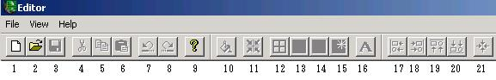

- New File
- Open File
- Saves File
- Cut
- Copy
- Paste
- Undo
- Redo
- Help
- Fill
- Snap to On/Off - When on, Sprites snap to the grid, which is a grid of 16x16 pixcls.
- Grid Overlay On/Off - When active, a grid is overlayed across the Map View window to assist in alignment and positioning of sprites.
- Palette Window On/Off - When active, the CFS viewer is present.
- Radar View On/Off - When active, the Radar view is present.
- Refresh Radar View - When toggled, the Radar view is updated.
- Set Defaults
- Align Left - When active, this function aligns all selected sprites to the snap-to grid depending on the alignment chosen.
- Align Right - When active, this function aligns all selected sprites to the snap-to grid depending on the alignment chosen.
- Align Top - When active, this function aligns all selected sprites to the snap-to grid depending on the alignment chosen.
- Align Bottom - When active, this function aligns all selected sprites to the snap-to grid depending on the alignment chosen.
- Align centers - When active, this function aligns all selected sprites to the snap-to grid depending on the alignment chosen.

When you create a new map, you’ll notice two smaller windows appear on your screen. One is the Radar view and the other is your CFS viewer. The radar overview is essentially your mini map. The red rectangle will show what you’re currently focused on. It’s good to refresh your radar as you progress so you can see the changes made to the entire map. To refresh the Radar, toggle the “Refresh Radar” button on your tool bar

Radar
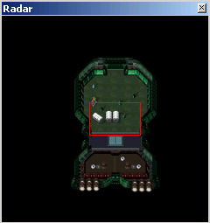

The CFS viewer (the second window on your screen) is what you’ll use to select your objects, vision, physics, and floor tiles. To switch between these fields, just click on the letter assigned to them. The legend for these is displayed below:

- F - Floor Tiles
- S - Objects or Sprites
- P - Physics Tiles
- V - Vision Tiles

CFS Viewer
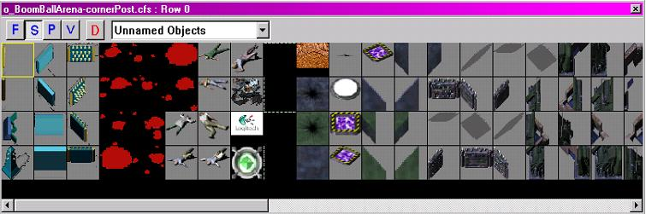

Sprites, Physics and Vision Overlays are all placed or painted into the Map View window. In the case of sprites, they are dragged from the Sprite Palette to the Map View. Physics and Vision Tiles are selected, then “painted on” using the left mouse button. Now might be a good time to scroll through the various objects and tiles, there are literally hundreds of assets to choose from. If you wanted to test out the placement of said objects, feel free. Please note you can delete any placed object by simply selecting it and pressing your “Delete” key.

Properties Window
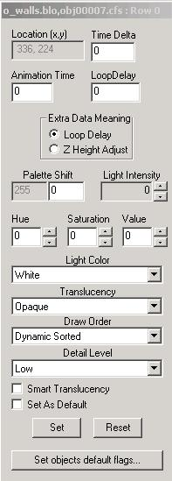

The properties window will appear anytime a Sprite is placed, such as a wall, box, pipe etc. From here, you can determine the properties of any placed Sprite on your map.

Let’s take a look at the options on the Properties Window starting from the top:

Location(x,y): In this box will be the map coordinates of the said placed Sprite. This field cannot be edited.
Time Delta: The time in ticks that an animated sprite will wait to start
Animation Time: The time in ticks that an animated sprite will play through one animation set.
Loop Delay: The delay in ticks that an animated sprite will wait to play through the next animation set.
Extra Data Meaning: This is a switch that tells the bltter whether the Loop Delay is used for delay, or as a Z Height adjustment.
Palette Shift: This is an unused function for palette shifting sprites.
Light Shift: This sets the value of a light palette sprite.
Hue: Changes the color of the selected object.
Saturation: This option determines how much color is in the selected object.
Value: This determines how bright you want the selected object to be.
Light Color: Sets the color of light palette sprites.
Translucency: Sets the degree of alpha blend on the selected sprite.

Draw Order:

- Static First - Drawn underneath (first) the player sprite
- Static Sorted - Drawn Above Static First, but under Player
- Static Last - Drawn above Static Sorted, but under Player
- Dynamic First - This allows a sprite to be animated. This level is drawn above all Static Sprites, but under Player.
- Dynamic Sorted - This is the same plane as the player, all sprites at this level sort with the player sprite.
- Dynamic Last - This layer is drawn last, and overlays the player. This option determines the order objects appear on the screen and also if the player can walk over, under or through the placed object.
- Detail Level: This determines the detail level of any selected object. The options are low, medium and high. By default the option is set to low.

Smart Translucency: This sets the smart translucency function whereby the sprite goes translucent at a certain distance from the player (in pixels) as defined in the zone .cfg file.
Set: Sets the options selected as defaults.
Reset: Resets options back to default setting.
Set Objects default flags: When selected this sets the current properties as the default values for all like sprites.

Now, let’s start making your map. It’s recommended that you start by placing your walls first. If mistakes are made, no problem, you can simply reshape or redo them at any time. Click on the CFS Viewer, hit the “S” button and use the drop down menu to scroll through the various assets. Sprites such as walls can be found in a number of places such as “2SWalls” or any of the “WallSets”. To place Sprites, simply select the object from the CFS viewer and drag it to your map.

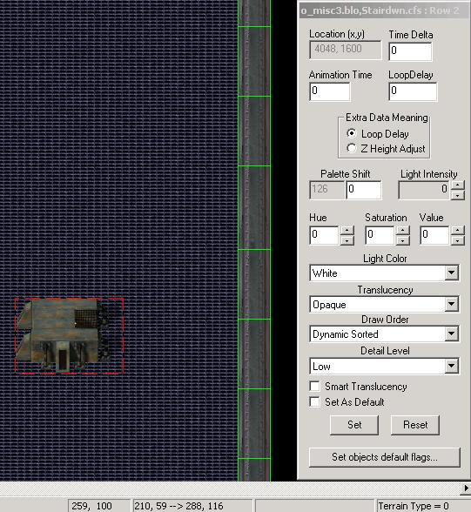

Above, we see a selected Sprite and the properties window. You’ll be able to tell when an object is selected as the properties window will always be displayed and said selected object is encompassed in a red rectangle. To unselect, simply click on another Sprite.

One important thing to note is some objects needs to be placed in relation to another object. Think of it as a large jigsaw puzzle. There are so many sprites and lots of combinations, so by all means, take your time.

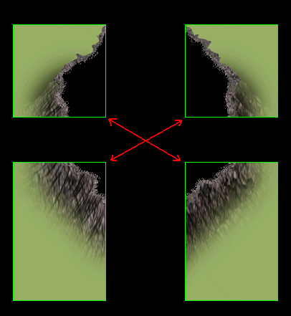

Once the walls are finished, select your floor tiles of choice and have at it. It’s important to note when placing floor tiles that you have the “Fill Selection” option turned off. You can toggle this option on/off under Edit>Fill Selection or, simply hit Ctrl+F. If you do not, you’ll be prompted by the editor that the tile option you’ve selected will fill over 200 tiles. This will encompass the entire map with the same texture. If this is not the desired effect, simply go to Edit>Undo. Make sure to fill all corners and make sure that the tiles do not exceed beyond your rooms. Afterwards, you can go back and add other objects to spruce up your map.

If you’ve finished adding walls, floors and landscapes, you can move on to adding physics to your map. When the Physics Button is pressed, the CFS viewer window will change to the Physics Palette. These tiles define the physics overlay and are all definable by right clicking on them.

Physics Palette
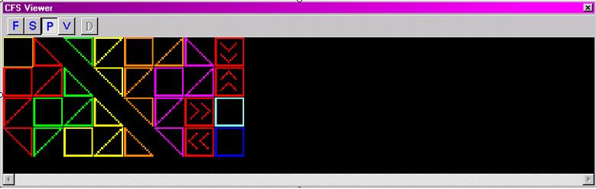

All physics have pre determined high and low points. The order from lowest to highest is Green, Yellow, Orange, Blue, Purple and Red. They are “Painted” onto the map via the Map View window using the left mouse button. You can also select an area in the map view and then use the “Fill” function to fill the selected area with the chosen physics tile. Right clicking on a selected physics tile will open a window that allows the user to set the low edge and high edge of a tile.

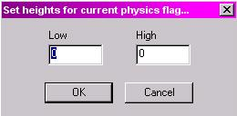

It is useful to think in terms of blocks or volumes when determining the correct values, at least in the case of Isometric Infantry maps.

The tiles with the directional arrows are one-way tiles; they allow projectiles or vehicles to pass when moving in the respective arrow direction and are considered solid from the opposite. If you ever get lost or confused on where to paint the physics, a good reference would be any of the maps already on the server. Just enter the zone and type ?showpyhsics in the chat bar. This will display all physics in the zone.

Vision Palette
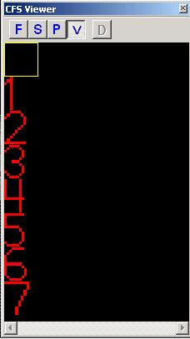

One of the last steps in the map making process is to add vision to your map. Setting vision on an object basically tells the player what they can or cannot see through. The vision tiles are defined in the zone .cfg file under [LosType] headings. Each number is represented by and LOS type. This allows the user a great deal of flexibility in defining LOS for the various map features.

1 - Good for rocks and walls. Players will not be able to see through it.
3 - Seen in use with trees and tree trunks.
4 - Players can see through if they are in very close approximation. Good for tree branches.
5 - Players can see through if they are in close approximation. Good for small boxes

Lastly, you can compile your map go going to File>Compile Map. The program will ask if you want to generate the radar bitmap. This image is what all players will see for the radar once uploaded onto the server. The file will be saved in the same location your map editor is in. Go ahead and hit yes to compile.

If you have some feedback or would like to see something added, please contact me at StationGamesFeedback@soe.sony.com.

